**Multiple Choice Questions**

**6 Events and Branding**

Question 1

An event as a product can become a brand. In addition, events can be used as an instrument for brand building. Image transfer plays a role here.

Statement: Which of the following descriptions best reflects what this concept means?

A The strategy in which, while retaining the brand name, the brand is expanded and transferred to new markets, target groups and moments of use.

B The strategy of a company that joins an event organized by other parties in order to strengthen its brand image.

C The strategy in which the image is conveyed to the consumer or visitors.

D The strategy in which the transfer of valuable associations for the consumer or the visitor from a brand to another brand, product or activity is central.

Question 2

Kapferer’s identity prism, the brand associative system and value patterns are analysis instruments which allow you to:

A Position brands in relation to each other.

B Link brands to events.

C Understand brands and assign meaning to them.

D Connect brands with products.

Question 3

Which statement is false?

A A brand is successful when it is capable of maintaining its added value under competitive pressure.

B A brand is aimed at creating added brand value.

C It is important to create brand associations around a brand.

D A product can always become a brand.

Question 4

John Kingsly is shopping for a new pair of jeans. In the Bijenkorf store he finally chooses a pair of Replay jeans. The store brand jeans looked the same, but he still prefers the more expensive brand item.

Statement: This is an example of:

A Brand equity.

B Brand image.

C Brand-added value.

D Brand value.

Question 5

Brands have several functions in the buying process.

Statement: What is not a function of a brand?

A Identification function.

B Assurance function.

C Symbolic function.

D Psychological function.

Question 6

An association network can be arranged in various ways. A means-end analysis shifts the relationship from attributes to values.

Statement: Put the following meaning structure analysis in the right order from concrete to abstract: 1 = instrumental values, 2 = functional consequences, 3 = abstract qualities, 4 = end values, 5 = concrete qualities, 6 = psychosocial consequences.

A 5, 3, 2, 6, 1, 4.

B 4, 1, 6, 2, 1, 3.

C 3, 1, 2, 6, 1, 4.

D 1, 3, 6, 2, 4, 1.

Question 7

Are the following statements true or false?

I Values play a central role in forming a person’s self-image or identity.

II A brand builder can reach more or less like-minded people in a society based on value patterns.

A Statement I is true, statement II is false.

B Statement I is false, statement II is true.

C Both statements are true.

D Both statements are false.

Question 8

Kapferer’s brand identity prism is a model to establish what a brand stands for (brand identity).

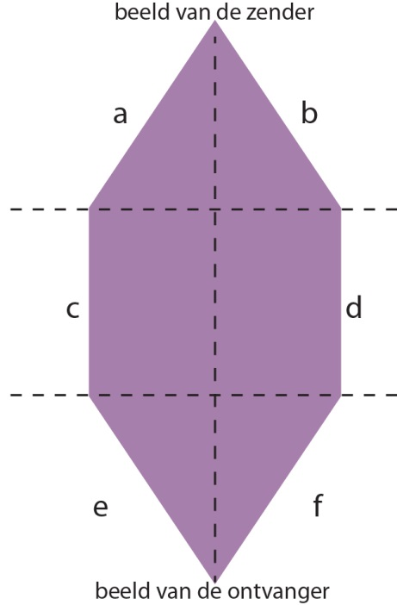

Statement: Within this model, reflection falls under facet:

A a.

B e.

C c.

D f.

Question 9

ABN AMRO has been sponsoring the ABN AMRO World Tennis Tournament for more than 35 years.

Statement: The brand strategy applied by ABN AMRO is a:

A Brand extension strategy.

B Endorsement strategy.

C Ingredient strategy.

D Co-branding strategy.

Question 10

Fashion magazine ***Grazia*** is organizing a fashion show in Breda in which all fashion stores located in the city centre take part.

Statement: This is an example of:

A Ingredient branding event.

B Sponsored event.

C Internal branding event.

D Sponsored (side) event.

Question 11

The corporate identity model of Groenendijk, Hazekamp and Mastenbroek and the spider web method of Bernstein are both models that:

A Identify the internal values of a brand or company.

B Identify the external image of a company.

C Provide insight into the internal and external image of a brand or company.

D Demonstrate the internal branding strategy.