**Multiple Choice Questions**

**1 Introduction: Events as a Strategic Marketing Tool**

Question 1

A trade show is an example of a:

A Business-to-employee event.

B Business-to-consumer event.

C Business-to-business event.

D Business-to-public event.

Question 2

The EVENTS model is based on the PDCA cycle.

Statement: Which components of this model take place in the ‘Plan’ phase?

A Setting goals, determining touchpoints and measuring effects.

B Environmental analysis, setting goals and translating strategy into concept.

C Determining touchpoints, going through the ‘Plan’ phase and measuring effects.

D Translating strategy into concept, determining touchpoints and environmental analysis.

Question 3

Which of the following statements is true?

A Business-to-business events are events where the target group is invited for business reasons and where the attendees participate out of a private leisure motivation.

B Business-to-consumer events are events where the target group is invited for business reasons and where the attendees participate out of a private leisure motivation.

C Business-to-consumer events are events where the target group is invited for leisure reasons and where the attendees participate out of a private leisure motivation.

D Business-to-employee events are events where a company’s personnel is invited for business reasons and where the attendees participate out of a private leisure motivation.

Question 4

In Breda, a fun fair is organized every year in the autumn holiday.

Statement: How can you best describe the objective of this fun fair, according to Kuiper’s four main objectives?

A Aesthetic.

B Idealistic.

C Entertainment.

D Commercial.

Question 5

The book describes the fading boundaries between corporate and public events. Insurance company Univé is taking its office staff on an outing to the World Gymnastics Championships.

Statement: Which segment does this team building activity fall under?

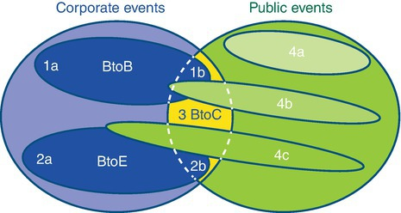

A 1a.

B 2a.

C 3.

D 2b.

Question 6

Which of the following statements is true?

A The point of departure in corporate events generally centres around subject matter content.

B Touchpoints only occur during the event itself.

C Sensory stimulation and emotions play an important role in events.

D The starting point in public events consists of the objective and the target group.

Question 7

What do the letters from the EVENTS model stand for?

A Environment, Value, Event, New, Touchpoints and Strategy.

B Environment, Value, Experience, New, Touchpoints and Strategy.

C Environment, Value, Evaluation, New, Touchpoints and Strategy.

D Environment, Value, Effect, New, Touchpoints and Strategy.

Question 8

What form of marketing is NOT discussed in the EVENTS model?

A Sales.

B Marketing communication.

C City marketing.

D Branding.