Adding a touch of pizzazz… with pictures!

We all like a good picture when reading a book. They help us understand the content, break up the text and even entertain us. But making sure your pictures are of a good quality is vital, or they can do exactly the opposite!

Follow our simple guide for selecting good figures and you won’t go far wrong.

- Relevance

Try to ensure that each figure you include is adding value – no one needs to see a picture of Auntie Edna if the book is about potato growing! (Unless, of course, your Auntie Edna is a particularly good potato farmer.)

- Recent

Provide recent photographs wherever possible – advances in camera technology mean the quality will be far higher, and people will be focusing on your point rather than the flamboyant flares of people in the background.

- Clarity

Fuzziness or graininess can give people the wrong idea about what you’re trying to show! Find a replacement if your image isn’t clear.

- Size

It sounds obvious, but a figure the size of a postage stamp won’t look great when shown at book page size…


=

- Resolution

This is where it gets technical! The resolution of an image file can be found by right clicking on the image in Windows Photo Viewer and selecting ‘properties’.

The resolution is shown in dpi – for photos, we want 300dpi and for line drawings, ideally 800dpi. The lower the resolution and pixel count, the lower the quality of the image, so try to make sure those numbers are as high as possible! This sloth is surprised to find he doesn’t pass the test…

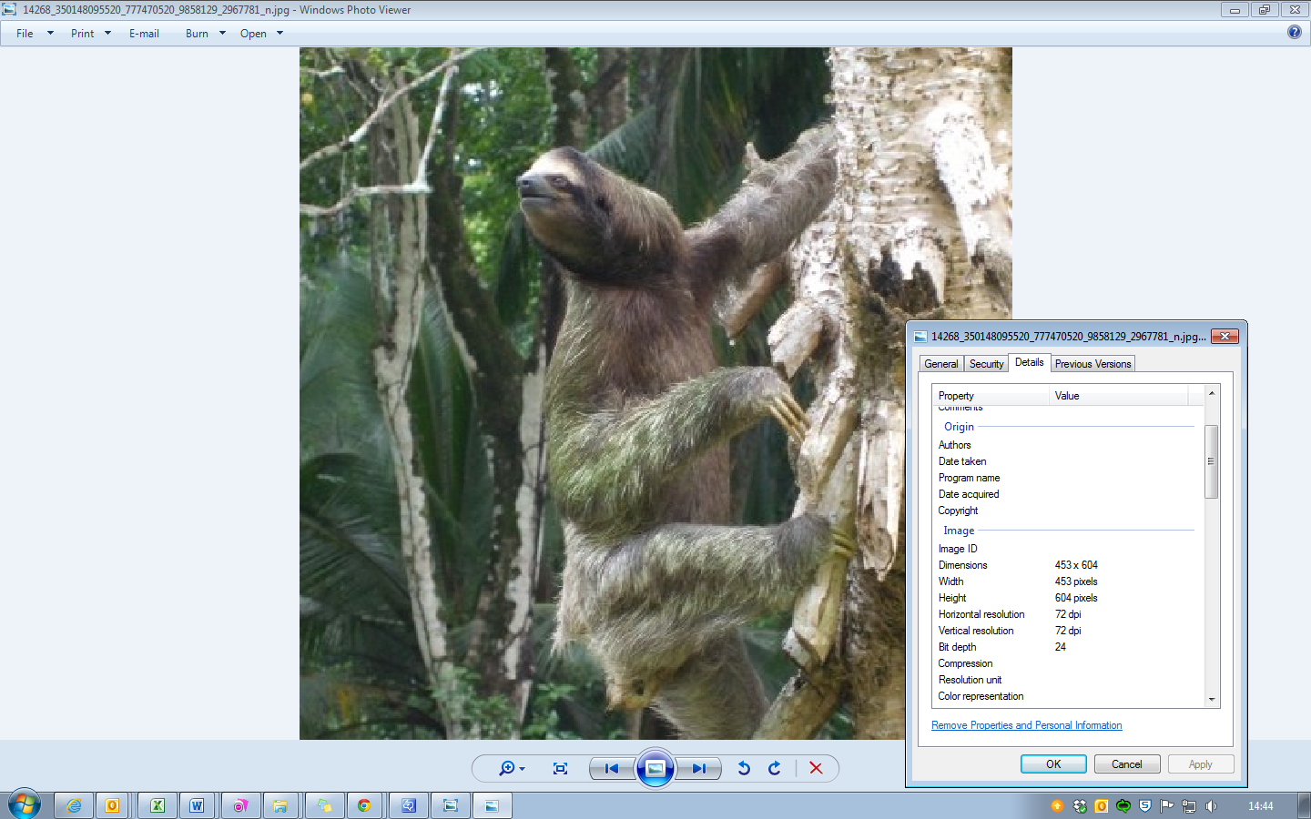

- Colour

Unless colour has been specifically agreed for your book, it will be printed in black and white (with photos in colour in the eBook). To make sure your point isn’t lost in the transition, make sure any figures reproduce well in black and white.

= 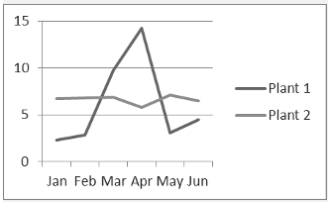

= 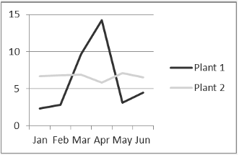

Good figures really enhance your book, so they’re worth considering from the start. For more information on quality, permissions and how to submit figures, check out our ‘Guide for Authors and Editors’!

